Analysis Report

Introduction

SecSuite is a comprehensive, modular cybersecurity suite designed to empower end-users—ranging from everyday social media users to corporate employees and journalists—to identify and mitigate online threats. The project integrates four core security functions into a unified platform: Social Media Bot Detection, Phishing Email Analysis, Fake News Verification, and Malicious Link Evaluation.
The primary objective is to enhance digital safety and promote informed decision-making by leveraging state-of-the-art machine learning (ML) and deep learning models to provide accurate, explainable threat assessments.

Current System
Currently, no single unified system integrates all these specific security checks into one user-friendly platform. Users typically rely on fragmented solutions:
- Bot Detection: Early systems used supervised machine learning with simple feature sets (e.g., posting frequency), but these struggle against coordinated botnets. More recent academic research has proposed graph-based approaches that utilize user connections for better detection. While these advanced ideas have been proposed and are in partial use within research contexts, they are not always accessible in a single, unified consumer tool
- Phishing & Link Checking: Users often rely on browser extensions or separate sites (e.g., VirusTotal) for link checking. Traditional phishing filters frequently fail against polished, LLM-generated attacks.
- Fake News: Fact-checking is largely manual or relies on disjointed databases, with deep learning approaches still maturing in terms of explainability.

Proposed System
SecSuite proposes a unified, web-based platform that consolidates these functions. It moves beyond simple binary classifications by providing explainable AI (XAI) insights (e.g., why an account is flagged as a bot).
- Unified Interface: A single dashboard for all four tools.
- Advanced Detection:
  - Bot Detection: Utilizes graph-based neural networks (GNNs) and behavioral analysis, leveraging datasets like TwiBot-22.
  - Phishing: Deploys advanced natural language processing to scrutinize message headers, body text, and embedded links for malicious intent.
  - Link Checking: Combines reputation database lookups (Google Safe Browsing) with ML/DL-based lexical and content analysis.
  - Fake News: Utilizes statistical analysis and classification algorithms to evaluate linguistic patterns and assess the credibility of the content.

Overview
The system is architected as a serverless application distributed on the edge.
- Frontend: Built with SvelteKit and Tailwind CSS, offering a responsive UI for inputting queries and visualizing results.
- Backend: A Hono.js API running on Cloudflare Workers, ensuring low latency (<50ms) and global availability.
- Data & ML: Uses Cloudflare D1 (SQLite) for storage, Cloudflare KV for caching results (24h TTL), and Cloudflare Workers AI (ONNX models) for inference.

Functional Requirements
The system shall perform the following functions:
- Bot Detection:
  - Accept a social media username or URL.
  - Analyze network graph (followers/followees) and content.
  - Return a "Bot" or "Human" classification with a confidence score and behavioral visualization.
- Phishing Detection:
  - Accept email headers and body text separately.
  - Identify high-risk elements (suspicious links, urgent language) and return a safety score.
- Fake News Detection:
  - Accept raw text or a news article URL.
  - Extract text from URLs and assess credibility using linguistic analysis.
- Link Checker:
  - Accept a URL, perform DNS/WHOIS lookups, and query threat databases.
  - Render a safe screenshot of the destination for user preview.
- General:
  - Support user authentication (JWT/OAuth) to save analysis history.
  - Provide an API for programmatic access.

Nonfunctional Requirements

- Performance:
  - Bot detection response time: ≤ 10 seconds.
  - Link/Phishing/Fake News response time: ≤ 6-8 seconds .
  - Support at least 100 concurrent users and 500 concurrent requests.
- Reliability & Availability:
  - System uptime ≥ 99.5%.
  - Recovery Time Objective (RTO) ≤ 15 minutes.
- Security:
  - All data encrypted via TLS 1.2+.
  - Input sanitization to prevent injection attacks.
- Usability:
  - Responsive design supporting desktop and mobile.
  - Internationalization support (English/Turkish).

Pseudo Requirements (Implementation Constraints)

These represent the technical constraints and standards mandated for the project:
- Tech Stack: Must use TypeScript for both frontend and backend.
- Infrastructure: Must be deployed on Cloudflare Workers (Serverless).
- Database: Must use DrizzleORM with Cloudflare D1.
- Testing: Must use Vitest for testing with ≥ 90% code coverage target.
- Compliance: Must adhere to GDPR and KVKK regulations (no PII storage unless permitted).
- Output Format: API must serve JSON responses documented via OpenAPI.

System Models

Scenarios (User Stories)

- Scenario 1 (End User): A user receives a suspicious email with a link. They copy the email text into SecSuite’s Phishing detector to get a safety score, then paste the link into the Link Checker to verify its destination without clicking.
- Scenario 2 (Journalist): A journalist wants to verify a viral Twitter thread. They input the author's username into the Bot Detector to see if the account exhibits coordinated bot behavior before citing it.
- Scenario 3 (Social Media Analyst): An analyst logs in to their dashboard to review past queries and analyze trends in bot activity they have tracked over the last month.

Use Case Model

- Actors: Guest User, Authenticated User, Administrator.
- Use Cases:
  - Analyze User Profile (Includes: Fetch Data, Generate Graph, Inference).
  - Check Phishing Email (Includes: Parse Header, Analyze Body).
  - Verify News Credibility (Includes: Extract Text, NLP Analysis).
  - Evaluate URL (Includes: WHOIS Lookup, Safe Browsing API Check).
  - View History (Authenticated User only).
  - Manage API Keys (Authenticated User only).

Object and Class Model

- User: (ID, Email, PasswordHash, Preferences, HistoryID)
- AnalysisRequest: (RequestID, UserID, Timestamp, InputData, RequestType)
- AnalysisResult: (ResultID, RequestID, Score, Confidence, ReasoningJSON, CacheKey)
- CacheEntry: (Key, Value, ExpiryTime).
- LogEntry: (LogID, Timestamp, Level, Message, StackTrace).

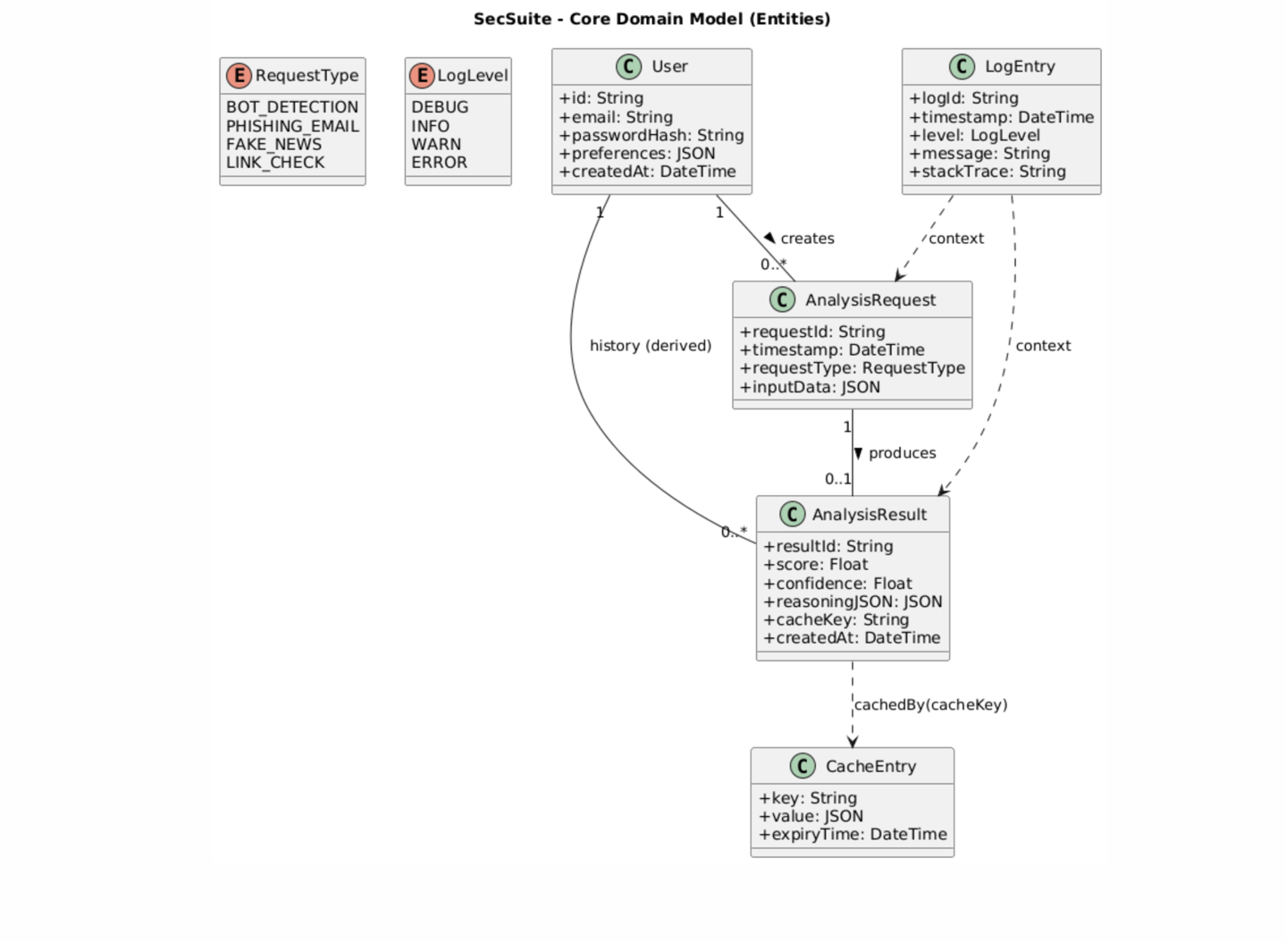

Dynamic Models

Sequence: Bot Detection Workflow
- User submits Username.
- API checks Cache (KV).
  - If Hit: Return cached result.
  - If Miss: 3. Bot Service calls Social Media API (fetch profile/posts). 4. Bot Service constructs Social Graph. 5. Inference Engine runs GNN Model. 6. Inference Engine runs Ensemble Classifiers . 7. Service aggregates scores & generates explanation. 8. Service stores result in Database (D1) & Cache.
- API returns JSON response to User.

User Interface

Navigational Paths:
- Landing Page: Overview of 4 tools -> Click Tool Card -> Tool Specific Input Page.
- Tool Input Page: Input Form -> Submit -> Loading State -> Results Dashboard.
- Auth Flow: Login/Signup -> User Dashboard (History/Stats).
Screen Mock-up Descriptions:
- Dashboard (Bot Detection):
  - Input: Text box for "Enter Username".
  - Output: A gauge chart showing "Bot Likelihood %".
  - Visualization: A D3.js force-directed graph showing the user's network cluster.
  - Details: A list of "Key Indicators" (e.g., "High posting frequency," "generic username").
- Link Checker Result:
  - Visual: A blurred screenshot of the target site (safely rendered).
  - Indicators: Red/Green status banner (Safe/Malicious).
  - Tech Details: Accordion list showing Redirect Chain, WHOIS Age, and SSL status.

Glossary

- API (Application Programming Interface): Interfaces for software interaction.
- Bot: Automated software controlling a social media account.
- GNN (Graph Neural Network): Deep learning model designed for graph-structured data.
- Hono.js: A small, fast web framework for the Edges.
- KV (Key-Value): Cloudflare's global low-latency storage.
- MVP: Minimum Viable Product.
- NLP: Natural Language Processing.

References

Project References:
- Cresci S., "A Decade of Social Bot Detection," 2020.
- Feng S. et al., "TwiBot-20: A Comprehensive Twitter Bot Detection Benchmark," 2021.
- Mannocci A. et al., "MULBOT: Unsupervised Bot Detection Based on Multivariate Time Series," 2022.
- Feng S. et al., "TwiBot-22: Towards Graph-Based Twitter Bot Detection," NeurIPS 2022.
- Uddin M. A., Sarker I. H., "An Explainable Transformer-based Model for Phishing Email Detection," 2024.
- Islam M. R. et al., "A Comprehensive Review on Fake News Detection With Deep Learning," IEEE Access 2021.
- Zhang X. et al., "URLNet: Learning a URL Representation with Deep Learning for Malicious URL Detection," NDSS 2018.
- DARPA Challenge (2016) - The DARPA Twitter Bot Challenge (Subrahmanian et al.) - Link
- Orabi, M. et al. (2020) - Detection of Social Bots on Twitter: A Survey - Link
- TAMU InfoLab - Social Honeypot Dataset - Link
- OSoMe - Botometer Datasets - Link
- Ferrara, E. et al. (2016) - The Rise of Social Bots - Link

